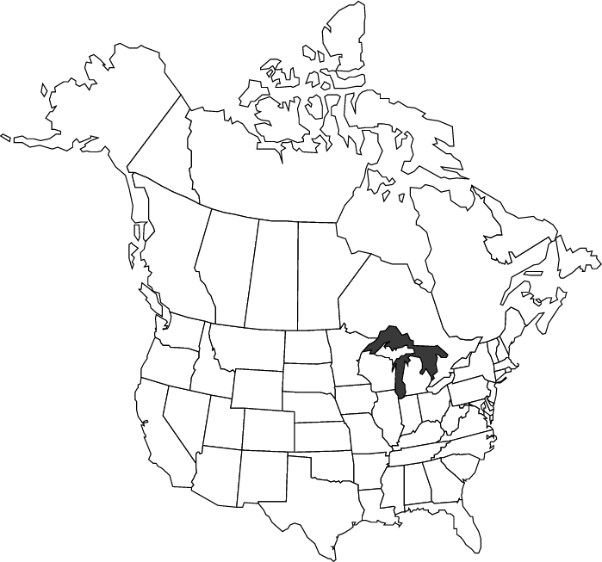

Label and Shade the following:

|  |  |  |
| --- | --- | --- |
| **Canada and United States** | **Major Landforms** | **Natural Resources** |
| Yukon | Great Lakes | coal |
| Northwest Territories | Mississippi River | petroleum |
| Nanavut | Canadian Shield | natural gas |
| British Columbia | Great Plains | iron ore |
| Alberta | St. Lawrence River | gold |
| Saskatchewan, | Rocky Mountains | silver |
| Manitoba | Piedmont | minerals |
| Ontario | Appalachian Mountains |  |
| Quebec | Rio Grande River |  |
| Newfoundland | Hudson Bay |  |
| Labrador | Yukon River |  |
| New Brunswick | Gulf of Mexico |  |
| Nova Scotia | Cascade Range |  |
| Prince Edward Island | Arctic Ocean |  |
| All 50 States | Atlantic Ocean, |  |
|  | Pacific Ocean |  |
|  | Coast Range |  |
|  | Sierra Nevada Range |  |
|  | Mount McKinley |  |