Countries | 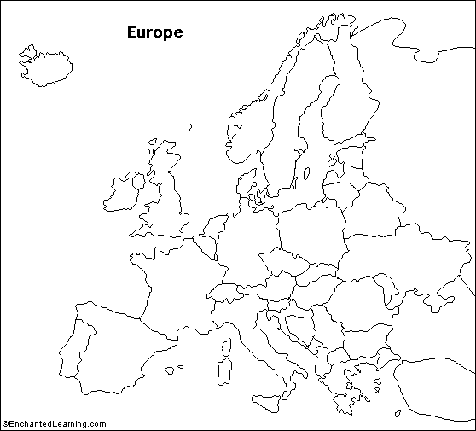  Countries
Albania | Liechtenstein
Andorra | Lithuania
Austria | Luxembourg
Belgium | Macedonia
Bosnia and Herzegovina | Malta
Bulgaria | Monaco
Croatia | Netherlands
Czech Republic | Norway
Denmark | Poland
Estonia | Portugal
Finland | Romania
France | San Marino
Germany | Slovakia
Greece | Slovenia
Hungary | Spain
Iceland | Sweden
Ireland | Switzerland
Italy | United Kingdom
Latvia | Vatican City
 | Yugoslavia

Major Landforms | Major Waterways
Scandinavian Peninsula | Thames River
Iberian Peninsula | English Channel
Jutland Peninsula | North Sea
Balkan Peninsula | Baltic Sea
Pyrenees Mts. | Rhine River
Alps | Danube River
Apennines Mts. | Po River
Balkan Mountains | Seine River
Carpathian Mts. | Mediterranean Sea
Ural Mountains | Adriatic Sea
Kjolen Mountains | Aegean Sea
Dinaric Alps | Black Sea
Great Hungarian Plain | Strait of Gibraltar
Northern European Plain | Arctic Ocean
British Isles | Atlantic Ocean
Corsica
Sardinia
Sicily
Crete
Cyprus

