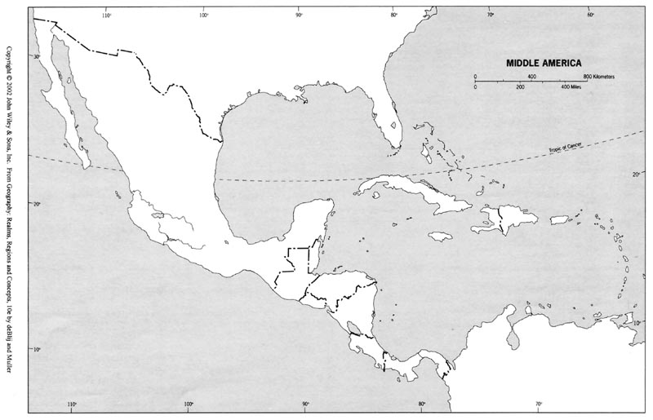

|  |  |  |  |  |  |  |
| --- | --- | --- | --- | --- | --- | --- |
| **Countries** | **Countries** | **Countries** | **Island Regions** | **Landforms** | **Landforms** | **Bodies of Water** |
| Mexico (test 1) | Dominican Republic (test 1) | Haiti (test 1) | Greater Antilles (test 1) | Andes Mountains | Brazilian Highlands | Caribbean Sea |
| Belize(test 1) | Jamaica (test 1) | Ecuador (test 2) | Lesser Antilles (test 1) | Llanos | Amazon Basin | Atlantic Ocean |
| Guatemala (test 1) | Puerto Rico (test 1) | Brazil (test 2) | Falkland Islands (test 2) | Patagonia, | Guiana Highlands | Pacific Ocean |
| Honduras (test 1) | Bahamas (test 1) | Peru (test 2) | Galapagos Islands(test 2) | Pampas |  | Gulf of Mexico |
| El Salvador (test 1) | Colombia | Bolivia (test 2) |  | Orinoco River |  | Strait of Magellan |
| Nicaragua (test 1) | Venezuela | Chile (test 2) |  | Amazon River |  |  |
| Costa Rica (test 1) | Guyana | Paraguay (test 2) |  | Sierra Madre Oriental |  | Test 1-September 19 |
| Panama (test 1) | Suriname | Uruguay (test 2) |  | Sierra Madre Occidental |  | Test 2-September 26 |
| Cuba (test 1) | French Guiana | Argentina (test 2) |  | Mato Grasso Plateau |  |  |