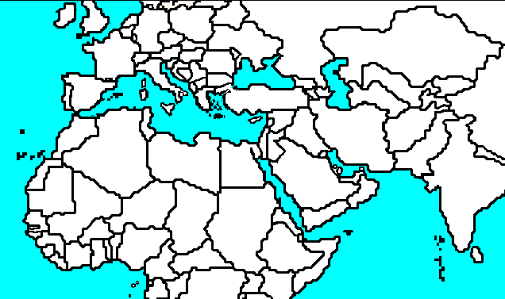

Unit 6 Map Quiz: Nov. 14
Use pages 424, 425, 433,449, 472, 473, 483 to label the countries and bodies of water and to shade in the landforms.
Countries | Bahrain | Landforms | Anatolian Plateau | Bodies of Water | Suez Canal
Western Sahara | Cyrus | Syrian Desert | Plateau of Iran | Tigris River | Straits of Gibraltar
Morocco | Israel | Hindu Kush |  | Nile River | Dead Sea
Algeria | Jordan | Sahara Desert |  | Euphrates River
Tunisia | Oman | Arabian Desert |  | Jordan River
Libya | Qatar | Libyan Desert |  | Mediterranean Sea
Egypt | Saudi Arabia | Great Salt Desert (Dasht-E-Kavir) |  | Black Sea
Afghanistan | Turkey | Arabian Peninsula |  | Caspian Sea
Iran | Yemen | Atlas Mountains |  | Persian Gulf
Iraq | United Arab Emirates | Ahaggar Mountains |  | Gulf of Oman
Kuwait | Island Regions | Taurus Mountains |  | Arabian Sea
Syria | Canary Islands | Pontic Mountains |  | Gulf of Aden
Lebanon | Madeira Islands | Zagros Mountains |  | Red Sea

